Laparoscopic Suturing Course
25th March 2019
Teaching and learning Centre
Queen Elizabeth University Hospital
Glasgow G51 4TF
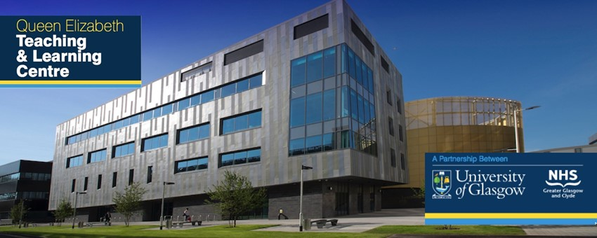

This one day laparoscopic Suturing practical course provide laparoscopic simulation based practise of advanced laparoscopic suturing skills using models. The course is designed for registrars and consultants who wish to refine their laparoscopic suturing techniques.

The course will be guided by experienced faculty. It will cover port placement for lap suturing, effective needle handling and placement of both curved and straight needles, interrupted and continuous suturing, passing needle through tissues, intracorporeal and extracorporeal laparoscopic knot techniques.

Faculty:

Veenu Tyagi Mohammed Allam
Chris Hardwick Karen Guerrero

Programme

9:30 - 10:00 Registration and coffee

10:00 - 10:05 Welcome

10:05 - 10:20 Ergonomics of laparoscopic suturing Veenu Tyagi

10:20 -10:45 Laparoscopic suturing – systematic Chris Hardwick
approach

10:45 - 12:45 Practical workshop 1 All Faculty

12:45 - 13:30 Lunch

13:30 - 15:45 Practical workshop2 All Faculty

15:45- 16:00. Feedback and certificates

