Laparoscopic Suturing Course
22nd November 2019
Teaching and learning Centre
Queen Elizabeth University Hospital
Glasgow G51 4TF
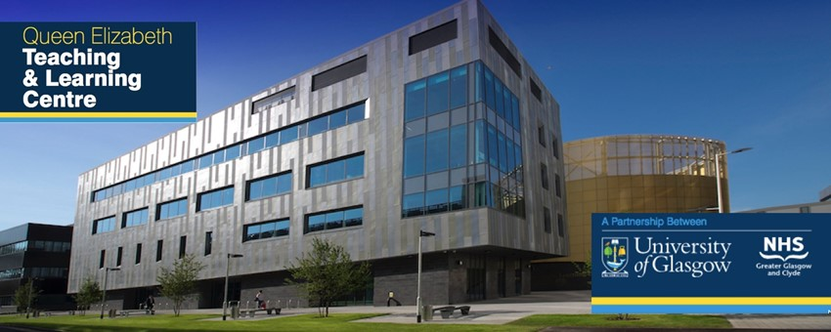

This one day laparoscopic Suturing practical course provide laparoscopic simulation based practise of advanced laparoscopic suturing skills using models. The course is designed for registrars and consultants who wish to refine their laparoscopic suturing techniques.

The course will be guided by experienced faculty. It will cover port placement for lap suturing, effective needle handling and placement of both curved and straight needles, interrupted and continuous suturing, passing needle through tissues, intracorporeal and extracorporeal laparoscopic knot techniques.

Faculty:
Veenu Tyagi Mohammed Allam
Karen Guerrero

Fees and Registration:
The course fees is £200. Cheque made payable to “Urogynaecology Research Fund”. Limited spaces available. For any querries and to register for the course please contact Veenu.Tyagi@ggc.scot.nhs.uk

Please fill in the registration form below and send to Sharon Black on address below.
Administration Corridor first floor
1345 Govan Road,Maternity Building
Queen Elizabeth University Hospital, G51 4TF

For information about our other courses please visit
http://www.urogynaecologyglasgow.scot.nhs.uk/
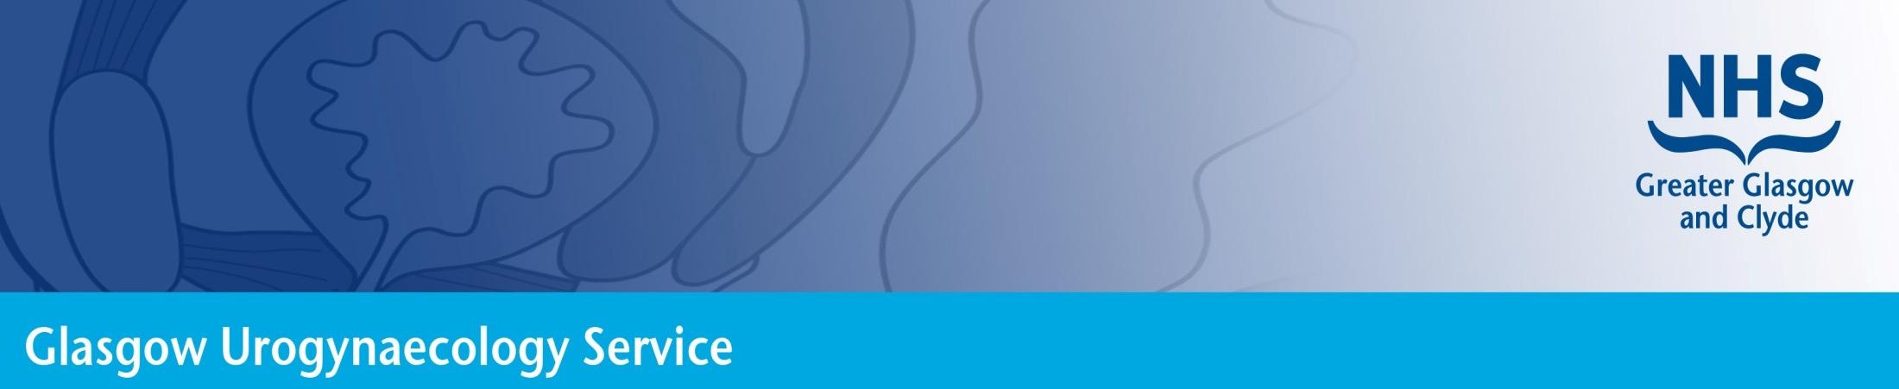

Laparoscopic Suturing Course
Glasgow November 2019

Your Details
Title | First name | Last name
Department |  | Hospital
Address for correspondence
Postcode |  | Telephone
Email |  | Job title
GMC number |  | Special dietary requirements

Your booking  
Please register me to attend the Laparoscopic suturing Course at a cost of £200
Mode of Payment (please delete as appropriate) | Cheque  Bank transfer

